Midterm Project

Zhaskanat

Car stock service

I have 4 microservices: Garage,Car,Brand,Model.

Brand and Model microservices supports main Car microservice.

Garage microservice connect whole 3 microservices.

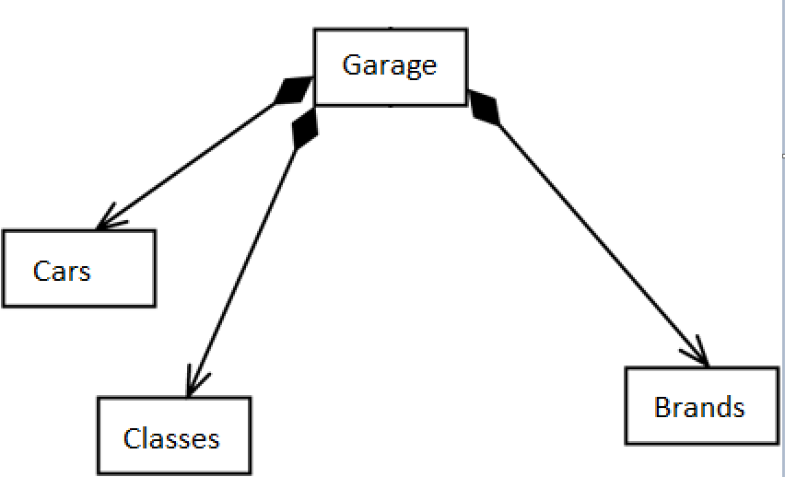

Microservices connect with each other with API controllers and each of them have own table I PostgreSql database

